Features or what RCI will do for SMEs

The basic criteria used to sort the operating problems is by deciding which management indicator on the CEO weekly management report will best control this issue / problem. Obviously most of these problems will impact more than one M, and identifying the main M that best controls it will make it easier for everyone.

All, if not most smes, use spreadsheets, especially Excel, Tableau, Air Tables and or some from of accounting system that manages some basic management information

Redhawk Consulting can leverage the decades of hands on experience helping companies analysis their operations, find operating problems and design solutions clients, subject matter experts to help the business operate much smoother, efficiently, boost profits and optimise cost. The gains, savings and improvements will consequently help increase sales, market share and profitability.

These are a comprehensive list of operating problems and issue RCI can identify and fix across all points of work execution who they manage every resources used for how they create economic value

Inefficient control over costs and quality
Poor stock control
Under pricing of goods sold
Loss of control through creditors' demands
Unable to account for stocks and raw materials
High scrap / rework / spoilage percentage
Low materials to finish goods conversion ratio
Missing or incorrect product identification: looking for stock that can't be easily found because it's in the wrong container, in the wrong area, or it doesn't have a move ticket
Waiting for material handling: raw stock or for finished goods to be moved away
Waiting at the stock room: due to improper location and inventory control
Needed material not in stock: due to lack of ordering or purchase follow-up
Batch assignment: which force first rush peaks, then lulls.
Inaccurate inventory control data
Insufficient working capital or gearing
Growth without adequate capitalization
Bad budgeting
Ignoring data on the company's financial position
Inadequate financial records
Extending too much credit
Bad credit control
Over borrowing or using too much credit.
Bad control over receivables
Loose control of liquid assets
Rework: although an employee is working, rework or scrap has been created
Poor discipline: early quits, excessive breaks etc. Do not overkill this point
No expectations of performance given or followed up on (i.e.)
Unscheduled setups: which cause delays from lack of trained set-up men or operators
Incorrect standards: which create misreported information
Improper compliance or non-compliance to scheduled preventive
Lines set up incorrectly. Mismatched capacities.
Illness of key personnel
Less than desirable relations with suppliers
Loss of key personnel
Lack of staff training
Weak personnel relations
Weak customer relations
Competition disregarded due to complacency
Employees walking around looking for work, their supervisor or just chit-chatting with other workers. Here lost time has a compound effect.
Over crewed job or positions, line imbalances
No reassignment to another job. Workers are left on their own
Supervisor out of area and not available as a resource.
Supervisor does work himself or does not train the worker. Supervisor does not prevent problems but rather contributes to it
Poorly skilled employees. slow, awkward pace and asking fellow workers for help
Proper tooling not available: either tool room can't find or inventory is depleted.
Excessive waiting for a tooling change or adjustment
Quantity problems, scrap, or rework
Incorrect blueprints or wrong spec sheets
Delays from poor communications: movement of stock between department / operations
Production reporting that is not timely: feedback the next day.
Supervisors ignoring new people: and letting "experienced guys" train them.
Misuse and shortages of material-handling equipment.
Jobs not laid out properly: or lack of readily available material, tools supplies, which causes excessive trips to the maintenance shop.
System non-compliance: lost time tracking down missing information.
Poor customer handling skills: ignoring or being rude to customers.
Lack of effective cross training: which limits flexibility especially on off shifts.
Operator non-attentiveness and non-compliance to scheduled quality and tooling checks
Processing work out of sequence, because it was not assigned.
Stationed filled issues
Failure to keep pace with management system
Failure to promote and maintain a favorable position
Inability of management to reach decisions
Loss of impetus in sales
Lack of knowledge of merchandise
Inability to cope adequately with competition
Failure to anticipate market trends
No work available. An employee literally runs out of work and must wait or go look for work ask his supervisor
Material not pre-staged. An employee finishes a job and must and is idle because there is no more material or work input
Poorly set-up work stations: lost time as the operator must walk to get raw stock
Working on the wrong part: running excess when a critical part remains in backlog
Machine down time: recurring machine problems which have not been properly resolved by maintenance. Check historical data
Machine utilization: one man running only 6 of an 8 machine complement.
Line imbalances or mismatched capacities: forcing hidden lost time
Lost time waiting for inspection or quality control checks:
Slow maintenance reaction time: either people are not available or there is no means of reporting needs to them
Improper maintenance priorities: eg. a machine is down while a set-up is being made.
No daily plan or schedule: to co ordinate the department.
Improper machine scheduling: which causes excessive setups, no family groupings
Product being run to the wrong machine: which causes low machine utilization.
Errors in the scheduling system or on work orders: wrong numbers, operations etc
No yardsticks or alarms to signal off schedule conditions.
No definite assignment for maintenance type people.

Below is a structured, product-ready blueprint for RCI – Root Cause Identifier, built directly from everything you provided. I’ve reorganised your long list of issues into a practical framework SMEs can understand, while making the system “tech-ready” for developers and funders.
I’ve also shaped it to fit Redhawk’s philosophy of the 4Ms + the CEO Weekly Management Indicator Model.

RCI (Root Cause Identifier) – Product Blueprint
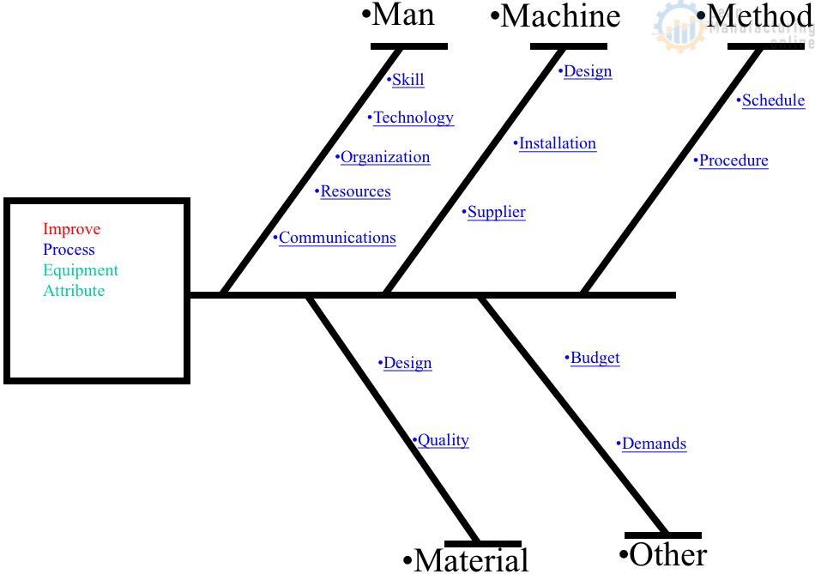
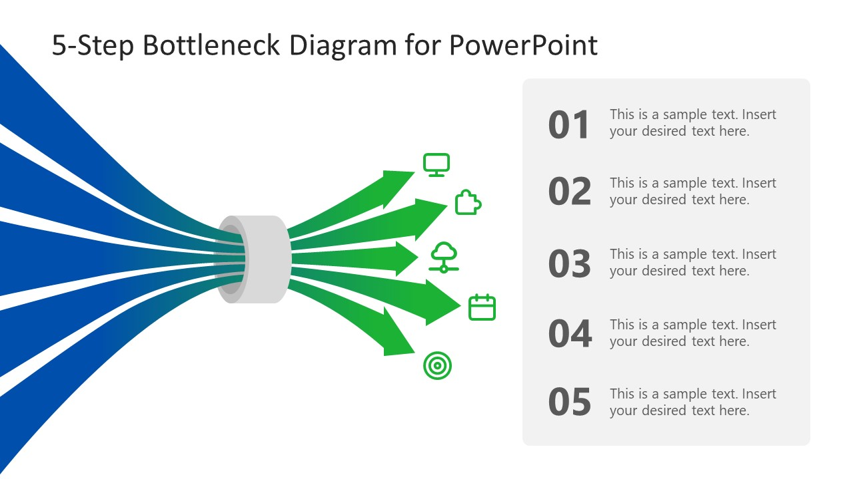

1. RCI’s Purpose
RCI helps SMEs find the root cause faster and solve it even faster, so operational problems do not recur.
It converts decades of Redhawk Consulting’s experience into a digital diagnostic engine that automatically:
- Detects operational problems early
- Pinpoints the correct 4M root cause (Money, Materials, Manpower, Machinery)
- Suggests practical, proven solutions
- Links each problem to the weekly management indicator the CEO must monitor
- Integrates with whatever tools SMEs already use (Excel, AirTable, accounting systems)

2. How RCI Works (Core Concept)

Step 1 — Capture Data From Existing Systems
RCI doesn’t force SMEs to change systems. It reads and interprets:
- Accounting data
- Stock sheets
- Excel / Google Sheets
- AirTable
- POS
- Basic ERP/CRM
- Production logs
99% of SMEs already have this data—RCI simply makes sense of it.

Step 2 — Automatically Classify Each Issue
RCI sorts every operational issue by:
- Which Management Indicator controls it
- Which of the 4Ms is the dominant root cause
Examples:
Problem | Dominant M | Indicator Trigger
High rework & scrap | Materials or Manpower | Quality Variance Indicator
Machine downtime | Machinery | Machine Utilisation Indicator
Bad credit control | Money | Receivable Aging Indicator
Stock not found | Materials | Inventory Accuracy Indicator
Poor discipline, long breaks | Manpower | Productivity Time-Loss Indicator
This gives CEOs one clear dashboard:
What’s wrong → Why → Which M → What action → Who is responsible

Step 3 — Provide Field-Tested Solutions
Each identified problem comes with:
- Explanation
- Likely root causes
- Recommended corrective action
- Estimated impact (cost, time, efficiency)
- Prevention steps (to avoid recurrence)
This is Redhawk’s advantage—your decades of case experience becomes a digital product.

3. The RCI Intelligence Library
Your long list of SME operational problems becomes RCI’s “problem engine.”
I have grouped everything into 8 Diagnostic Categories, making the system scalable.

Category 1: Financial Control Problems (Money)
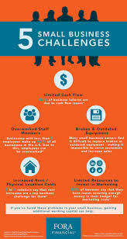
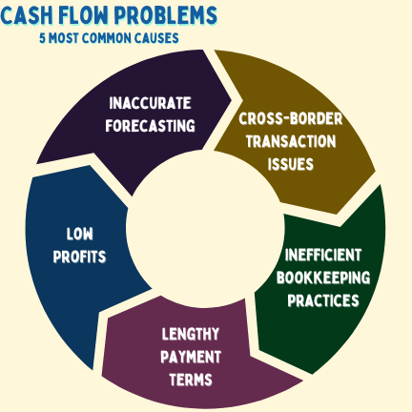
RCI Will Detect:
- Bad budgeting
- Ignoring key financial signals
- Over-borrowing / gearing issues
- Extending too much credit
- Poor receivables control
- Weak cash flow planning
- Inadequate financial records
- Growth without capitalization
- Weak liquid asset control
RCI Output:
- Root cause (e.g., underpricing, stock loss, margin leakage)
- Action plan
- Dashboard alert to CEO

Category 2: Inventory + Materials Problems (Materials)


Problems Detected:
- Poor stock control
- Missing stock / lost containers
- Wrong labeling / wrong bin locations
- No move tickets
- Waiting for material movement
- Materials not pre-staged
- Wrong raw material levels
- High scrap / wastage
- Incorrect standards / specs
- Poor conversion ratios
- Rework due to wrong materials
- Bad batch assignment
- Delays in internal logistics
RCI Outputs:
- Which area failed (store, purchasing, handling, production)
- Root 4M cause
- Material flow map improvements
- Preventive controls

Category 3: Production Efficiency Problems (Machinery + Manpower)
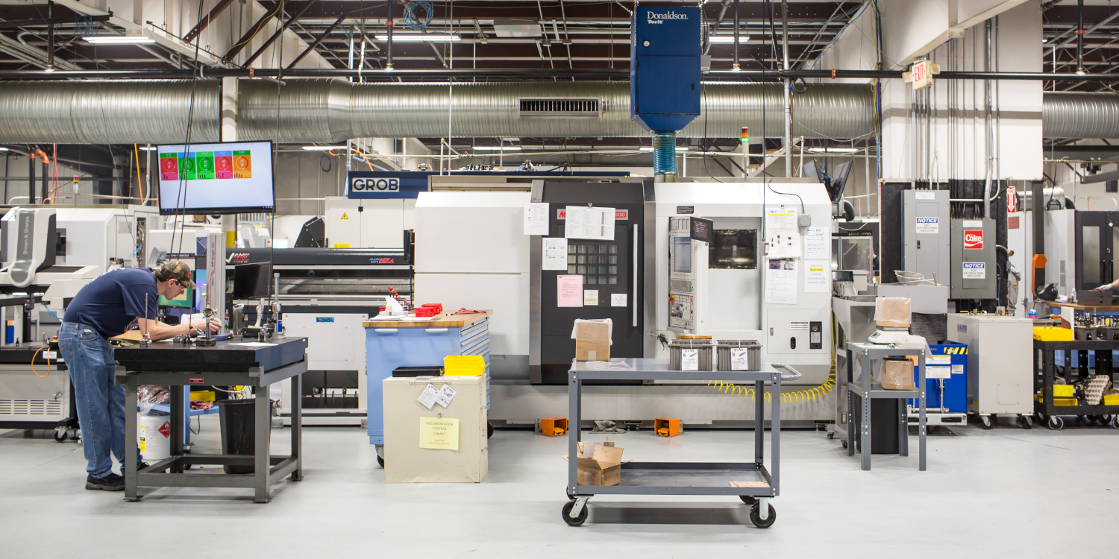
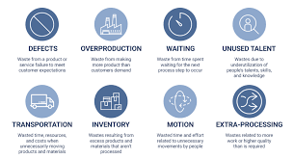
Key Issues Detected:
- Long waiting time between processes
- Line imbalances
- Incorrect routing / out-of-sequence processing
- Poor workstation setup
- Machine downtime
- Improper maintenance priorities
- Excessive manual handling
- Wrong machine scheduling
- Slow maintenance response
- No daily plan
- No yardsticks to detect delays
- One man running less than full machine complement
RCI Provides:
- Real-time alerts
- Bottleneck identification
- Predictive maintenance triggers
- Capacity balancing tips

Category 4: Workforce Problems (Manpower)
Problems Detected:
- Slow, poorly trained workers
- Excessive chit-chat, wandering, breaks
- Lack of cross-training
- Weak supervision
- Supervisor doing operator work
- Improper training
- Poor discipline
- Loss of key personnel
- Staff illness impact
- No work reassignment
- Poor operator compliance
- HR not aligned with operations
RCI Outputs:
- Skills gap mapping
- Efficiency loss measurement
- Training and redeployment suggestions
- Supervisor performance alerts

Category 5: Quality Problems (Materials + Manpower)
Issues Detected:
- Rework
- Scrap
- Quantity mistakes
- Incorrect part or blueprint
- Missed quality checks
- Wrong machine settings
- Bad customer handling skills
Actions Provided:
- Root cause 4M identification
- Quality loop closure steps
- Preventive checklists

Category 6: Sales + Customer Issues (Money, Manpower)
Issues:
- Loss of impetus in sales
- Weak customer relations
- Lack of merchandise knowledge
- Failure to track competition
- Failure to anticipate trends
Outputs:
- Sales process diagnostics
- Customer experience scoring
- Product-market alignment alerts

Category 7: Strategic/Management Issues
Issues:
- Inability to make decisions
- Complacency
- System non-compliance
- Failure to follow management systems
- Poor communication between departments
- No schedule, no plan, no assignment
- No alignment between management and operations
RCI Outputs:
- Escalation paths
- Management meeting templates
- CEO-level strategy diagnostics

Category 8: Work Execution Problems (Cross-4M Issues)
These are your “hidden lost time” issues:
- Workers looking for work
- Running wrong part
- No material ready
- Jobs not laid out
- Over-crewed or under-crewed stations
- Poor communication between departments
- Wrong specs
- Wrong machines used
- System not updated
- No performance expectations set
- No signals for off-schedule conditions
RCI turns these into measurable KPIs:
- Lost Time Score
- Flow Efficiency
- Supervisor Effectiveness

4. Why RCI Is a Game Changer for SMEbank, Pernas & SMEs
RCI helps their clients:
- Reduce operating costs
- Improve stock accuracy
- Increase yield
- Improve manpower efficiency
- Reduce rework/scrap
- Improve cash flow
- Increase output without new machines
- Improve profitability
- Prepare the SME for expansion and even listing (IPO readiness)
SMEs get a smoother business, and banks get stronger, more investable customers.

5. Business Model (Subscription)
Here is a recommended pricing framework for Malaysia:

RCI Subscription Pricing
Tier | Monthly Fee | Suitable For
Starter | RM 199 / month | Micro SMEs, retail, small shops
Standard | RM 499 / month | SMEs with 10–50 staff
Professional | RM 899 / month | SMEs with production, warehousing
Enterprise | RM 1,500–2,500 / month | Larger factories, multi-branch
Add-ons:
- Customisation: RM 3,000–20,000 per project
- Onsite consulting: RM 2,500 per day
- Training: RM 600 per session

6. Next Step
If you want, I can now produce:
✅ The RCI product description for grant submissions
✅ The RCI brochure (sales copy)
✅ The RCI pitch deck for Tom, SMEbank, Pernas
✅ A full RCI diagnostic engine architecture (developer-friendly)
✅ The RCI module workflow in Odoo
Just tell me:
Which one would you like me to generate next?

